Soundscape Reflection

Paul Lewis

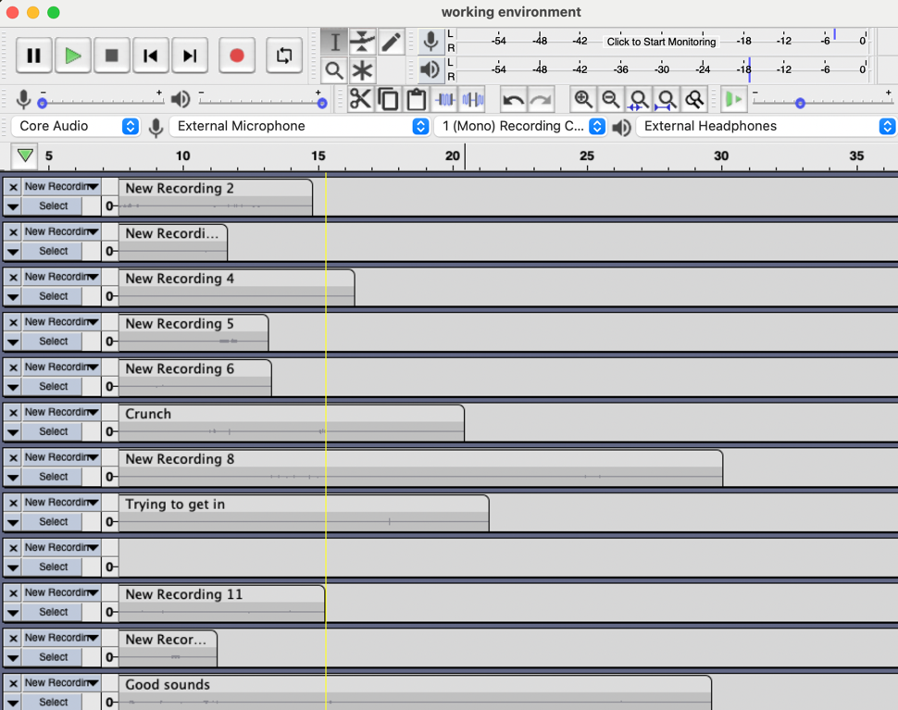 I ended up having more difficulty completing my soundscape than I anticipated initially. Working with sound editing programs is somewhat new to me but the thing I really didn’t expect was how hard it would be to record and source some of the sounds I wished to use. As the project progressed I was able to slowly create a workflow in which I used one audacity session as a working space for splicing up and editing clips before moving them into the audacity session where I edited the main soundscape. This made it simpler to sort through the many recordings and find the parts I wanted without being overwhelmed. I also learned how to troubleshoot common audacity issues like rescanning for audio devices or converting between stereo and mono sounds. One thing I wish I did earlier was combine some of the tracks into one track that encompassed a category of sounds. Using a dedicated track for just one sound effect feels a little silly and definitely slows down the workflow by cluttering the screen. Another issue I found was that it was very hard to stick to my original script. Some things which in writing seemed like they might take equal amounts of time didn’t seem to last as long as I expected in the actual soundscape. Working with sound allows a lot of flexibility with the rate at which time passes and you can imply hours passing with a few simple transitions. This is a project I hope to come back to when working on the final portfolio but I will have to be content to leave it as it is for now in order to focus on the next unit working with visual media. Below I have included a screenshot of the finalized version.

